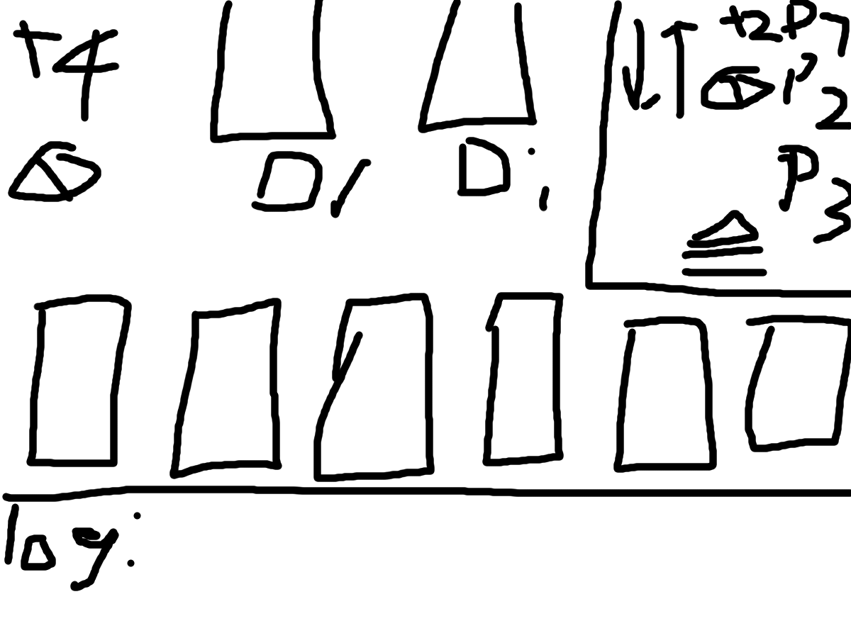

+4 top left: Shows the number of cards the current is going to have to draw. The color of the number should match the color of the previous card that +2ed them (If last card is wild and stackable then either display black or rainbow effect).

Skip top left: Shows the play they’ve just been skipped

DR square: Draw square. Can be clicked on to draw a card but cards can also bee drawn through a hotkey

DI square: Discard square where the top card is shown

Box top right: Displays the current players with current effects such as draws or skips

To Do:

Add hurry button to can be pressed to automatically send hurry in the messages and will appear next to the player who pressed it. (Cannot be pressed when it’s their turn)